**Detailed Business Specific Requirements:-**

**Theme**: Existing IT system for internal agencies of MoJS

**Applications**: WIMS expansion-WRIS

**Use Cases:-** Jal-ltihaas-**WRIS-SSA-07**

**Other linked Use Case :-** N/A

**Description**:-

Water heritage structures are a vital component of India's rich cultural heritage. The deep understating of its significance need to established to preserve the water heritage structures exist in the country. The geo-mapping of the water heritage sites could lead to create an inventory of these structures to gain a comprehensive overview of the state of water conservation and augmentation in the country which can ensure the availability of the heritage sites information to the future generation.

**Used By (End Users):-** Planners, Decision makers, administrators, academicians, Farmers, and the public in general.

**Priority**:- **Low Priority-** this application is not interlinked With any DSS of the WARIMS portal.

**Phase:-** **Phase 1**

**Governance Need (Business Problem):-**

**Issue**:- Data received from State and Central Agencies are in the .pdf format which can not be directly incorporated in the database. Multiple heritage structures are shown on a same point. Data will be manipulated on various boundaries for better visualization.

**Approach**:- The location of water heritage sites should be in proper geospatial format which need to validated with Ground Control Points for proper visualization.

**Output:-**

**Expected Outcome:-** Jal ltihaas will provide a comprehensive view of water heritage structures of the country, allowing for a better understanding of their historical significance and importance.

**Visualization:-**

**1. Map:** Geolocation of water heritage sites in the country will be shown with respect to;

* **Political Boundaries**
* **State**
* **District**

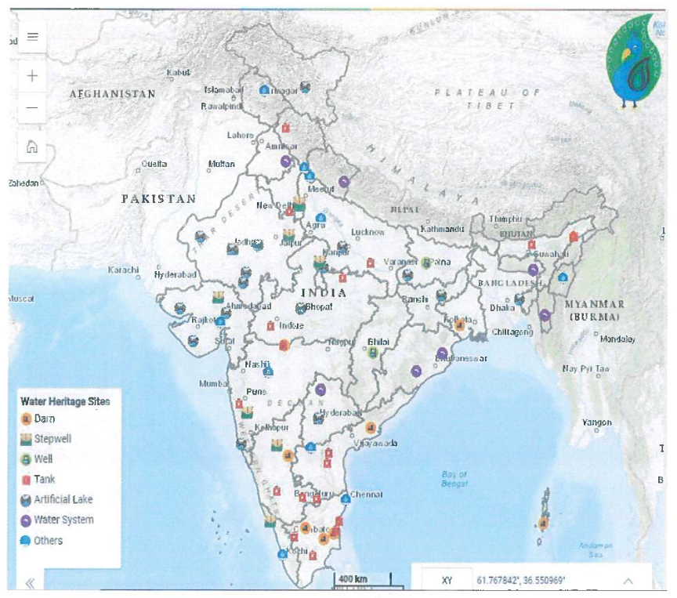

(A). Water Heritage Structures at India Level

**User Selection:** When the user clicks on the location of water heritage site in an application, the below mention table will pop-up on the screen with key salient features of the heritage sites so that the user can easily identify them.

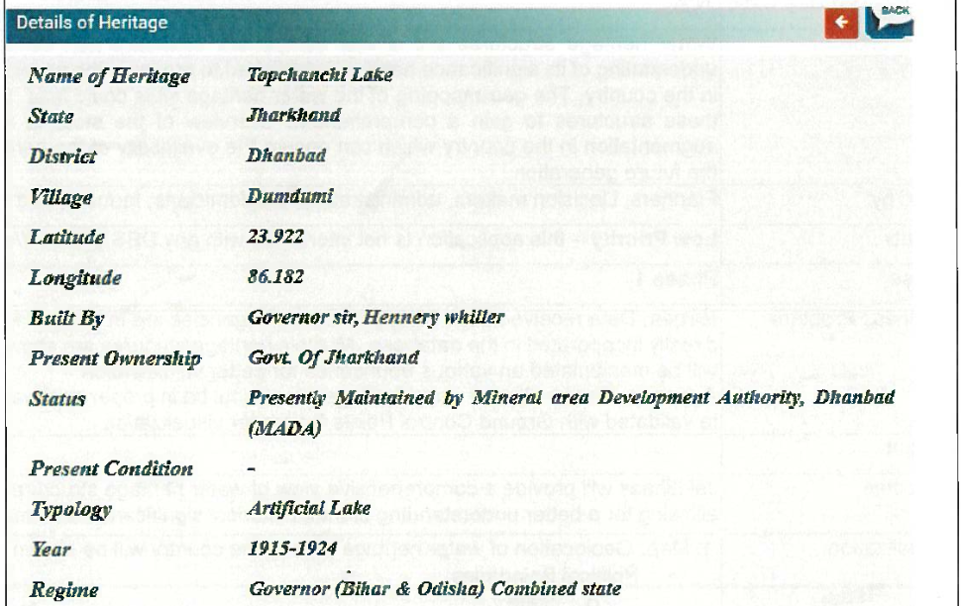

**2. Graph / Charts:**

(X-Axis : State name, Y-Axis: Count of water heritage sites)

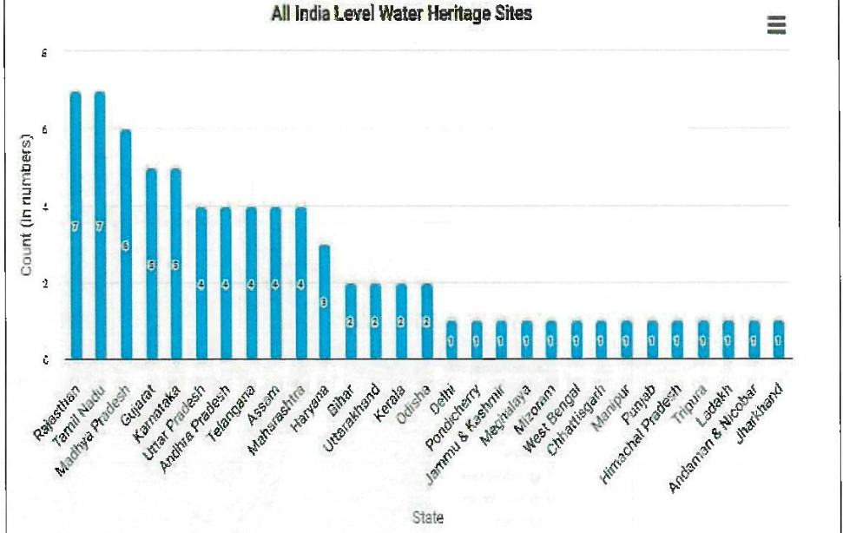

**3.Output on Tabular Form**

|  |  |  |  |  |  |
| --- | --- | --- | --- | --- | --- |
| **Sr.No** | **Heritage Name** | **State** | **District** | **Type** | **Year** |
| 1 | Panighat Aqueduct | Andaman & Nicobar | South Andamans | Dam | During British Period |
| 2 | k.c.canal Aqueduct Across Handri River | Andhra Pradesh | Kurnool | Others | 19th Century |
| 3 | Sir Arthur Cotton Barrage (Dholeshwaram Anicut) | Andhra Pradesh | East Godavari | Dam | 1852 |
| 4 | Porumamilla Tank (Anantharaja sagaram) | Andhra Pradesh | YSR Kadapa | Tank | 1869 |
| 5 | Cumbum Tank | Andhra Pradesh | Prakasham | Tank | 1522-1524 AD |
| 6 | Bor Pukari or Sivasagar Tank | Assam | Sivasagar | Tank | 1734 |

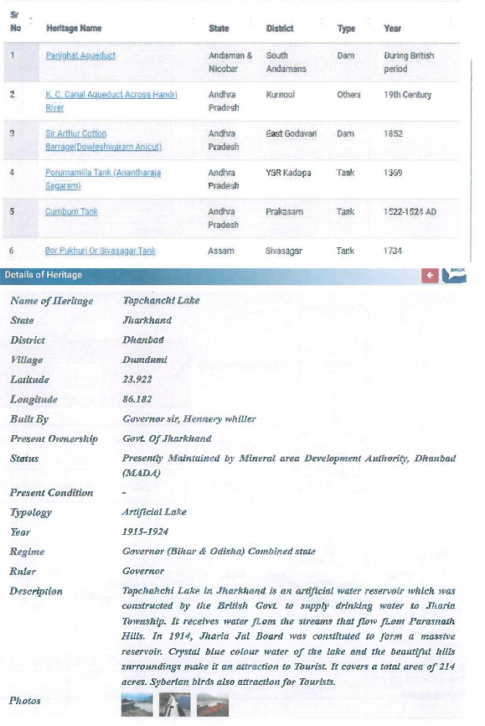

**Frequency of Up-dation:-** Static in Nature, However, data Will be updated as per their availability.

**Measure of Success:-** The application shows a comprehensive view of water heritage structures, allowing for a better (KPIls) understanding of their historical significance and importance.

**Input Data Required:-**

|  |  |  |  |  |
| --- | --- | --- | --- | --- |
| **Sr. No** | **Data point** | **Type** | **Unit** | **Data Provider** |
| 1 | Name of Heritage | String | Text | **National Water Mission** |
| 2 | Latitude | Float | Degree Decimal |
| 3 | Longitude | Float | Degree Decimal |
| 4 | Region | String | Text |
| 5 | State | String | Text |
| 6 | District | String | Text |
| 7 | Village | String | Text |
| 8 | Built by | String | Text |
| 9 | Present ownership | String | Text |
| 10 | Status | String | Text |
| 11 | Present Condition | String | Text |
| 12 | Topology | String | Text |
| 13 | Year | String | Text |
| 14 | Regime | String | Text |
| 15 | Ruler | String | Text |
| 16 | Photographs | String | hyperlink |

**Process:**

**Algorithm/Tools:-**

Representation of Water heritage Structures on map and heritage Information on the users defined queries).

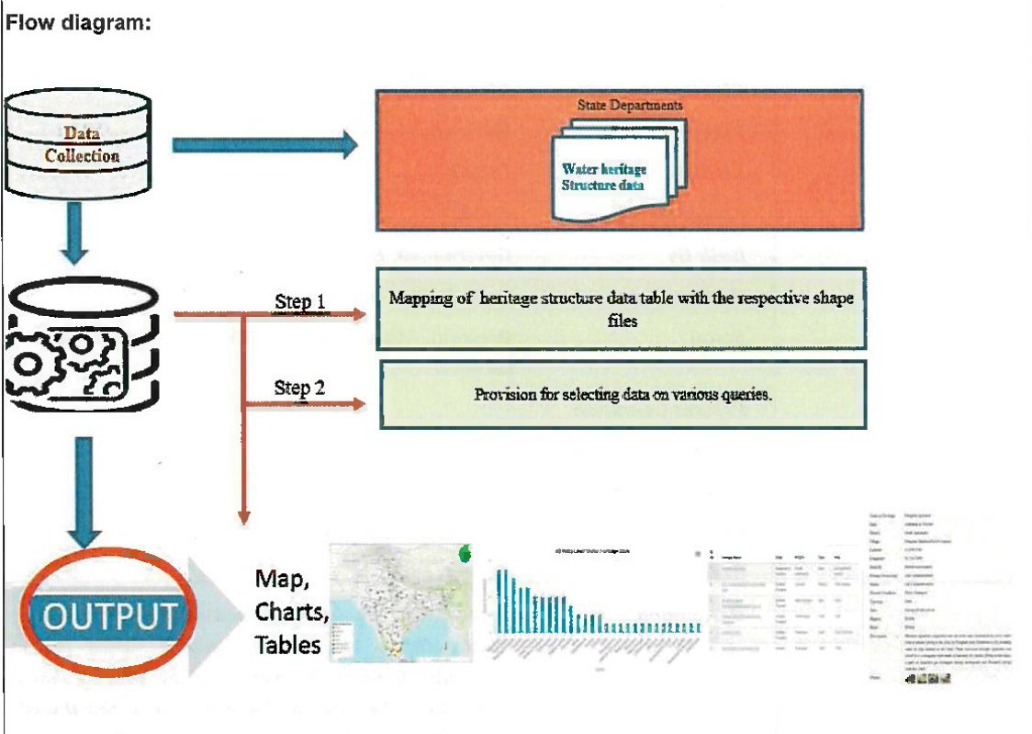

**Step 1:** Mapping of heritage Structure data table with the respective shape files.

**Step 2:** Provision for selecting data on various Queries.

**Data Validation:-** Water heritage Structures Information data may require validation before use.

**Software Technologies:-**  QGIS, Python, Angular

**Dependencies & Risks:** Data availability With Source agencies.

**User Acceptance Testing (UAT):-** NWIC

**Development Responsibility:** NWIC

**References :-** <https://indiawris.gov.in/wris/#/jalithihaas>

**---End of Document---**